 

Q1:

Software Requirements Specification

for

Bird Boarding Booking System

Version 1.0 approved

Prepared by

Nguyen Van A

Campus ?

02/04/2024

Q2:

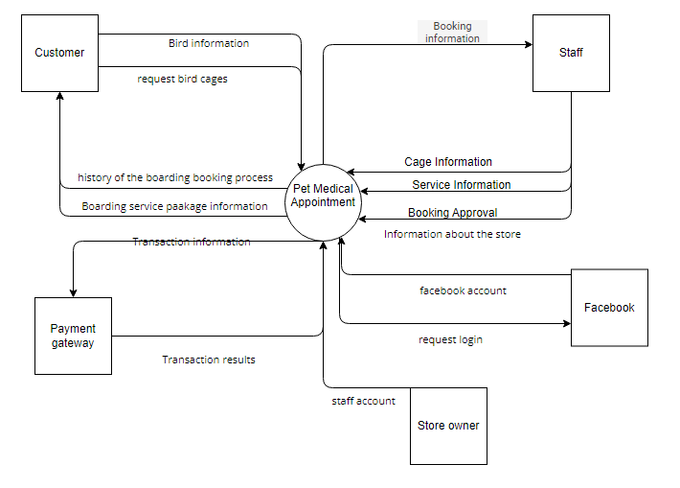

Q3:

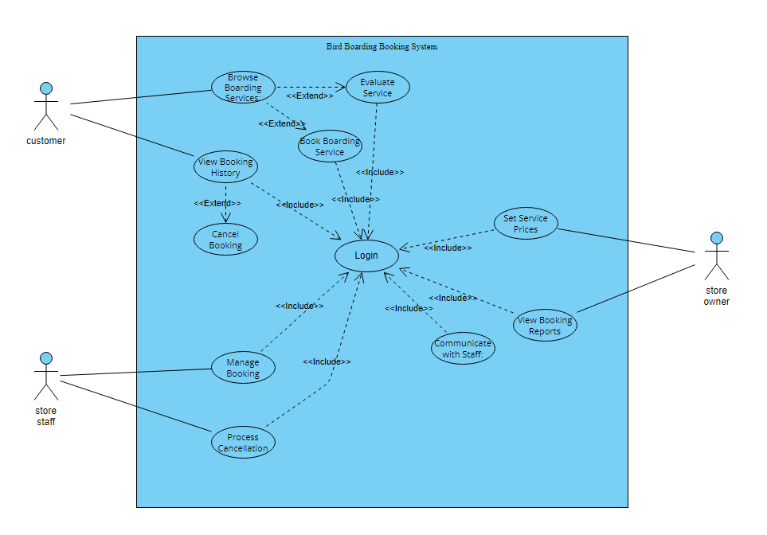

|  |  |  |
| --- | --- | --- |
| **#** | **Actor** | **Description** |
| 01 | Customer | This is the primary actor who interacts with the system to browse services, book boarding, view booking history, cancel bookings, communicate with staff, and potentially evaluate services. |
| 02 | Store staff | This actor manages bookings on behalf of the store, including reviewing booking requests, approving customer accounts, and potentially communicating with customers through the chat function. |
| 03 | Store owner | The owner sets service prices and receives booking reports. |

|  |  |  |  |
| --- | --- | --- | --- |
| **#** | **Use Case** | **Actors** | **Description** |
| UC-01 | Browse Boarding Services | Customer | Customer explores available boarding services and package details. |
| UC-02 | Book Boarding Service | Customer | Customer books a boarding service for their bird(s), including selecting a service, specifying dates/times, choosing a cage (or allowing system assignment), reviewing fees, and making payment. |
| UC-03 | View Booking History | Customer | Customer reviews their past boarding booking information. |
| UC-04 | Cancel Booking | Customer | Customer cancels an existing booking, considering cancellation policies and fees. |
| UC-05 | Communicate with Staff | Customer | Customer chats with store staff through the system for inquiries or concerns. |
| UC-06 | Evaluate Service | Customer | Customer provides feedback and ratings on their boarding experience. (Optional) |
| UC-07 | Manage Booking | Store staff | Staff reviews and manages boarding bookings, including approving customer accounts, viewing booking details, and potentially communicating with customers through the chat function. |
| UC-08 | Process Cancellation | Store staff | Staff handles customer booking cancellations, applying cancellation fees as per policy. |
| UC-09 | Set Service Prices | Store owner | Owner defines pricing for different boarding services through an external interface |
| UC-10 | View Booking Reports | Store owner | Owner receives reports on booking activity and performance through an external interface. |
| UC-11 | Login | All | Customer accounts registered with the system must be approved by store staff or store owner before being used to log into the system. The system shall lock a customer's account after five consecutive unsuccessful logon attempts within a period of four minutes |

Q4:

< Student must replace this line, answer of Q4 by fill the content to below table that reflect this exam paper

Notes:

1. Describe >= 5 business rules (1.5 point)
2. For each incorrect business rule, 0.3 points will be deducted

>

|  |  |  |
| --- | --- | --- |
| ID | Rule Definition | Use cases |
| BR-01 | A customer account must be approved by store staff or owner before being used for booking. | UC-10, UC-02 |
| BR-02 | Only one customer's birds can be housed in a single bird cage at a time. | UC-02 |
| BR-03 | The boarding service fee is calculated based on a per-bird/cage/day structure. | UC-02 |
| BR-04 | Customers receive a 50% discount on additional birds placed in the same cage as the first bird. | UC-02 |
| BR-05 | Secure online payment (PayPal or VnPay) is mandatory for confirming a booking. | UC-02 |
| BR-06 | Customers can cancel a booking before a predefined period (set by the store owner) with a 50% cancellation fee. | UC-04 |
| BR-07 | Cancellations after the predefined period will result in a full fee loss. | UC-04 |

**Q5:**

a.Performance:

Reaction time: The framework will react to client activities (e.g. log in, look, book) inside an normal of 3 seconds amid crest utilization hours. This guarantees a smooth client encounter and dodges client disappointment when attempting to make a booking. Analyzers can degree reaction times utilizing different stack testing instruments and guarantee they meet indicated criteria.

Scalability: The framework must be able to handle expanding numbers of concurrent clients (e.g., 100 clients) without significantly corrupting execution. Usually critical to meet the spike in booking action amid top season. Analyzers can reenact tall user loads and screen reaction times, framework assets, and blunder rates to assess adaptability.

b. Security:

Data Encryption: All delicate client data (title, contact points of interest, installment data) must be scrambled both at rest and in travel utilizing industry standard calculations (e.g. AES- 256). This secures against unauthorized get to to private information within the occasion of a security breach. Analyzers can survey framework setup and documentation to affirm the utilize of fitting encryption strategies.

Account lockout: The framework will actualize an account lockout component after five successive unsuccessful login endeavors inside a four-minute period. This makes a difference avoid brute drive assaults and unauthorized get to endeavors. Analyzers can recreate login endeavors and confirm that the account locking instrument works as planning.

Ornamental bird store need to develop a web-based Bird Boarding Booking System that allows the customer to make bookings for bird boarding services at the store during busy periods. The system allows the customer to view detailed information about boarding service packages and bird cages available in the store. When booking a boarding service, the customer can choose the time period for depositing birds and the boarding service. The customer can specifically request bird cages in the store for the birds they need to send. In case the customer does not specify a bird cage, the store staff will choose the appropriate bird cage according to the customer's booking. According to store policy, a cage contains only birds that belong to one customer. The boarding service price is calculated for one bird/cage/day. In case the customer wants to send more than one bird in the same cage, the price will be reduced by 50% for each additional bird added to the cage. The system requires the customer to make payment through the online payment system (PayPal or VnPay) before the booking is recorded in the system. In case the customer cancels the booking before the time period set up in the system by the store owner, the customer will lose 50% of the amount paid. After this time, the customer will lose the amount paid for the boarding booking. The system allows the customer to view the history of the boarding booking process and allows for service evaluating the service after having used it. The customer can communicate with store staff through the system's chat function, communication information is recorded in the system. The boarding service price list is set by the store owner. Only the store owner has the right to cancel a customer's booking. The system allows customers to log in through an account registered with the system or using a Facebook account. Customer accounts registered with the system must be approved by store staff or store owner before being used to log into the system. The system shall lock a customer's account after five consecutive unsuccessful logon attempts within a period of four minutes. The application must use Microsoft .NET framework 4.8.

Cửa hàng chim cảnh cần phát triển Hệ thống đặt chỗ cho chim cảnh dựa trên web cho phép khách hàng đặt dịch vụ nuôi chim tại cửa hàng trong thời gian bận rộn. Hệ thống cho phép khách hàng xem thông tin chi tiết về các gói dịch vụ đưa đón và lồng chim có sẵn tại cửa hàng. Khi đặt dịch vụ lên máy bay, khách hàng có thể lựa chọn khoảng thời gian gửi chim và dịch vụ lên máy bay. Khách hàng có thể yêu cầu cụ thể lồng chim trong cửa hàng cho những con chim họ cần gửi. Trường hợp khách hàng không ghi rõ lồng chim, nhân viên cửa hàng sẽ chọn lồng chim phù hợp theo yêu cầu đặt hàng của khách hàng. Theo chính sách của cửa hàng, một lồng chỉ chứa những con chim của một khách hàng. Giá dịch vụ nội trú được tính cho một con/lồng/ngày. Trường hợp khách hàng muốn gửi nhiều chim vào cùng một lồng, giá sẽ giảm 50% cho mỗi con chim bổ sung vào lồng. Hệ thống yêu cầu khách hàng thanh toán qua hệ thống thanh toán trực tuyến (PayPal hoặc VnPay) trước khi việc đặt chỗ được ghi nhận vào hệ thống. Trường hợp khách hàng hủy đặt chỗ trước thời gian chủ cửa hàng thiết lập trên hệ thống, khách hàng sẽ mất 50% số tiền đã thanh toán. Sau thời gian này, khách hàng sẽ mất số tiền đã thanh toán cho việc đặt chỗ lên máy bay. Hệ thống cho phép khách hàng xem lịch sử quá trình đặt chỗ lên máy bay và cho phép dịch vụ đánh giá dịch vụ sau khi đã sử dụng. Khách hàng có thể giao tiếp với nhân viên cửa hàng thông qua chức năng chat của hệ thống, thông tin liên lạc được ghi nhận trong hệ thống. Bảng giá dịch vụ nội trú do chủ cửa hàng quy định. Chỉ chủ cửa hàng mới có quyền hủy đặt chỗ của khách hàng. Hệ thống cho phép khách hàng đăng nhập thông qua tài khoản đã đăng ký với hệ thống hoặc sử dụng tài khoản Facebook. Tài khoản khách hàng đăng ký với hệ thống phải được nhân viên cửa hàng hoặc chủ cửa hàng phê duyệt trước khi sử dụng để đăng nhập vào hệ thống. Hệ thống sẽ khóa tài khoản của khách hàng sau 5 lần đăng nhập không thành công liên tiếp trong khoảng thời gian 4 phút. Ứng dụng phải sử dụng Microsoft .NET framework 4.8.